Name : Alveena naz
Registration number: FA25-BSE-010
PF Lab activity 5

Activity 1:

import java.util.Scanner;
public class Firstjava
{
public static void main(String[] args)
{
Scanner input = new Scanner(System.in);
int num1 = (int)(Math.random() *10);
int num2 = (int) (Math.random() *10);
System.out.println("What is " + num1 + "+" + num2 + "=" +"?");
int result = input.nextInt();

while(num1 + num2!=result)
{
System.out.println("Wrong answer. Try again. What is " + num1 + "+" + num2 + "=" +"?");
result = input.nextInt();
}
System.out.println(" You got it.");
}
}

OUTPUT:
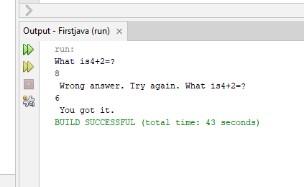

Activity 2:

import java.util.Scanner;
public class Firstjava
{
public static void main(String[] args)
{
Scanner input = new Scanner(System.in);
System.out.println("Enter the number of integers in the list:");
int limit = input.nextInt();
System.out.println(" Enter " + limit + " integers");

int count = 0;
int sum =0;
while(count<limit)
{
int number = input.nextInt();
sum+=number;
count++;
}
System.out.println(" The sum of " + limit + "integer is " + sum);
if(count!=0)
System.out.println(" The average is " + sum/count);
else
System.out.println(" No input");
}
}

OUTPUT:

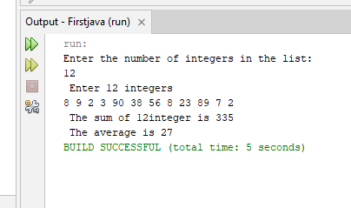

Activity 3:

import java.util.Scanner;
public class Firstjava
{
public static void main(String[] args)
{
Scanner input = new Scanner(System.in);
int sentinel = -999;
System.out.println("Enter positive integers" + "ending with " + sentinel );
int num = input.nextInt();
int sum = 0;
int count = 0;
while(num!= sentinel)
{
sum+=num;
count++;
num = input.nextInt();
}
System.out.println(" The sum of integer is " + sum);

if(count!=0)
System.out.println(" The average is " + sum/count);
else
System.out.println(" No input");
}
}

OUTPUT:

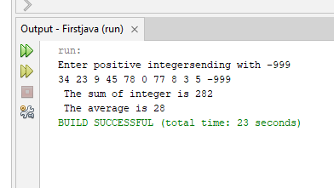

Activity 4:

import java.util.Scanner;
public class Firstjava
{
public static void main(String[] args)
{
Scanner input = new Scanner(System.in);
int num = (int)(Math.random() *100);
int guess;
while(true)
{
System.out.println("Enter an integer grater than 0 and less than 100:");
guess = input.nextInt();

if(guess==num)
{
System.out.println(" Your guess is correct");
break;
}
else if(guess >num)
System.out.println(" Your gues is greater than the number\n" + " guess again ");
else
System.out.println(" Your gues is less than the number\n" + " guess again ");

}

}
}

OUTPUT:

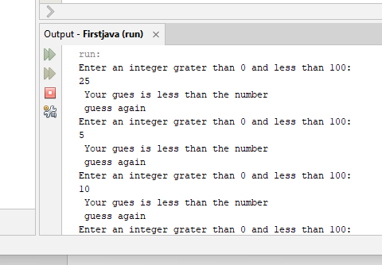

Activity 5:

import java.util.Scanner;
public class Firstjava
{
public static void main(String[] args)
{
Scanner input = new Scanner(System.in);
System.out.println(" Enter five integers");
int num;
int sum = 0;
for(int i = 1; i <=5; i++)
{
num = input.nextInt();
sum+=num;

}
System.out.println(" The sum is "+ sum );
}
}

OUTPUT:

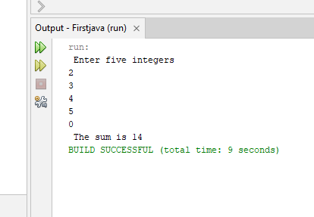

Activity 6:

import java.util.Scanner;
public class Firstjava
{
public static void main(String[] args)
{
Scanner input = new Scanner(System.in);
System.out.println(" Enter the numbers and 0 to quit");
int num = input.nextInt();
int max = num;
do
{
num = input.nextInt();
if(num>max)
max = num;
}while(num!=0);

System.out.println(" Maximum is " + max);

}
}

OUTPUT:

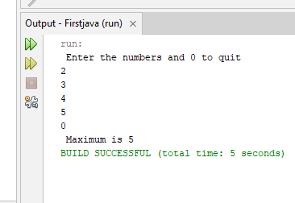

Activity 7:

import java.util.Scanner;
public class Firstjava
{
public static void main(String[] args)
{
Scanner input = new Scanner(System.in);
System.out.println(" Multiplication Table");
// Display table title
System.out.print(" ");
for(int i = 1; i<=9; i++)
System.out.print(" " +i);
System.out.println();
// Display Table number
for(int i =1; i<=9; i++)
{
System.out.print( i + "| ");
// Display Product
for(int j = 1; j<=9; j++)
System.out.printf("%4d" , i * j );
System.out.println();
}

}
}

OUTPUT:

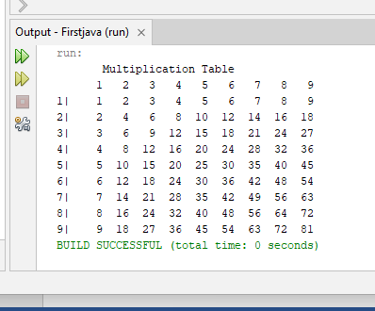

Activity 8:

import java.util.Scanner;
public class Firstjava
{
public static void main(String[] args)
{
Scanner input = new Scanner(System.in);
int sum = 0;
int num = 0;

while(num <20)
{
num++;
sum+=num;
if(sum>=100)
break;
}
System.out.println(" The number is " + num);
System.out.println(" The sum is " + sum);

}
}

OUTPUT:

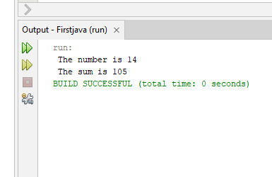

Activity 9;

import java.util.Scanner;
public class Firstjava
{
public static void main(String[] args)
{
Scanner input = new Scanner(System.in);
int sum = 0;
int num = 0;

while(num < 20)
{
num++;
if(num == 10 || num == 11)
continue;
sum+=num;
}

System.out.println(" The sum is " + sum);

}
}

OUTPUT:
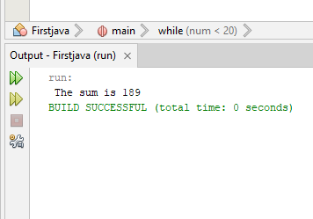

Graded Lab task 1: Part (a)

import java.util.Scanner;
public class FirstJava
{
public static void main(String[] argd)
{
Scanner input = new Scanner(System.in);
System.out.println("Enter 1st integer number:");
int num1 = input.nextInt();
System.out.println("Enter 2nd integer number:");
int num2 = input.nextInt();
for(int i = num1; i<=num2; i++)
System.out.print( i +" ");

}
}

OUTPUT:

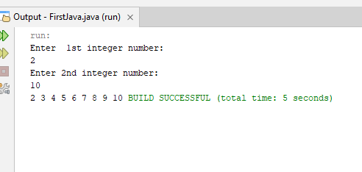

Part(b):

import java.util.Scanner;
public class FirstJava
{
public static void main(String[] argd)
{
Scanner input = new Scanner(System.in);
System.out.println("Enter 1st integer number:");
int A = input.nextInt();
System.out.println("Enter 2nd integer number:");
int B = input.nextInt();
if(A<B)
{
for(int i = A; i<=B; i++)
System.out.print( i + " ");
}
else
{
for(int i = A; i>=B ; i--)
System.out.print( i + " ");
}
}
}

OUTPUT:
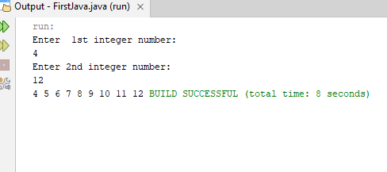

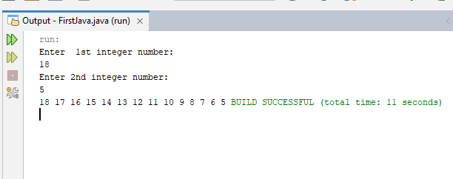

Part(c):

import java.util.Scanner;
public class FirstJava
{
public static void main(String[] argd)
{
Scanner input = new Scanner(System.in);
System.out.println("Enter the number of integers:");
int limit = input.nextInt();
System.out.println("Enter " + limit+ " integer");
int num;
int sum = 0;
for(int i = 1; i<=limit; i++)
{
num = input.nextInt();
sum+=num;

}
System.out.println(sum);
}
}

OUTPUT:

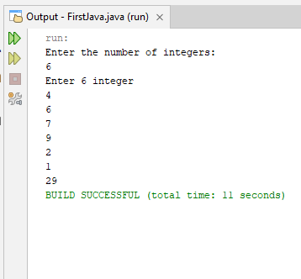

Part(d):

import java.util.Scanner;
public class FirstJava
{
public static void main(String[] argd)
{
Scanner input = new Scanner(System.in);
System.out.println("Enter a number:");
int num = input.nextInt();
int sum = 0;
int cube = 0;
for(int i = 1; i<=num; i++)
{
cube = i * i * i;
sum+=cube;

}
System.out.println(sum);
}
}

OUTPUT:
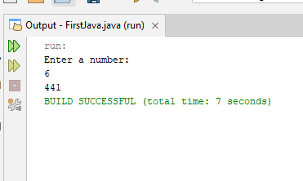

Graded Lab task 2:

import java.util.Scanner;
public class FirstJava
{
public static void main(String[] argd)
{
Scanner input = new Scanner(System.in);
System.out.println("Enter a number:");
int num = input.nextInt();
int fact = 1;
for(int i = 1; i<=num; i++)
{
fact*=i;

}
System.out.println(" The factorial of " + num + " is " + fact);
}
}

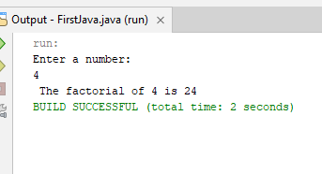
OUTPUT:

Graded Task 3:

import java.util.Scanner;
public class FirstJava
{
public static void main(String[] argd)
{
Scanner input = new Scanner(System.in);
System.out.println("Enter the number of your values:");
int limit = input.nextInt();
int num;
int count = 0;
System.out.print("Enter " + limit + " numbers");
for(int i = 1; i <=limit; i++)
{
num = input.nextInt();
if(num==0)
count++;
}
System.out.println( " The number of zeros is " + count);
}
}

OUTPUT:
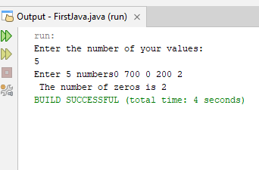

Graded task 4:

import java.util.Scanner;
public class FirstJava
{
public static void main(String[] argd)
{
Scanner input = new Scanner(System.in);
System.out.println("Enter the numbers:");
int number = input.nextInt();
int count = 0;
for(int i = 1; i <=number; i++)
{
if(number==0)
break;
count++;
number = input.nextInt();
}
System.out.println(count);
}
}

OUTPUT:
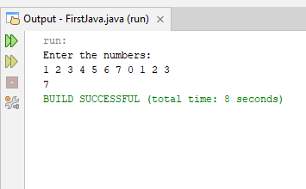

Graded task 5:

import java.util.Scanner;
public class FirstJava
{
public static void main(String[] argd)
{
Scanner input = new Scanner(System.in);
System.out.println("Enter the number and 0 to end the sequence:");
int num = input.nextInt();
int largest = 0;

while(num!=0)
{
if(num>largest)
largest = num;
num = input.nextInt();
}
System.out.println(" The largest number is " + largest);

}
}

OUTPUT:
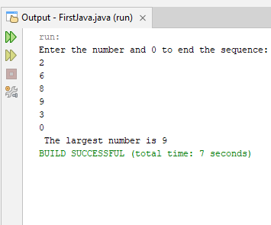

Graded task 6:

import java.util.Scanner;
public class FirstJava
{
public static void main(String[] argd)
{
Scanner input = new Scanner(System.in);
System.out.print("Enter the number and 0 to end the sequence:");
int num = input.nextInt();
int max = 0;
int index = 0;

while(num!=0)
{
if(num> max)
{
max = num ;
index++;
}
num = input.nextInt();
}
System.out.println(index);

}
}

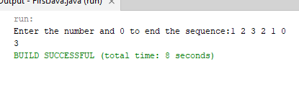
OUTPUT:

Graded task 7:

import java.util.Scanner;
public class FirstJava
{
public static void main(String[] argd)
{
Scanner input = new Scanner(System.in);
System.out.print("Enter the number and 0 to end the sequence:");
int num = input.nextInt();

while(num!=0)
{
if(num%2==0)
{
System.out.println(num);
}
num = input.nextInt();
}

}
}

OUTPUT:

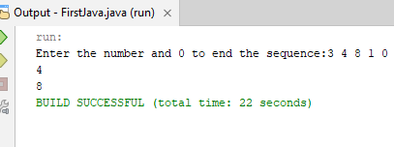

Graded task 8:

import java.util.Scanner;
public class FirstJava
{
public static void main(String[] argd)
{
Scanner input = new Scanner(System.in);
System.out.print("Enter the number and 0 to end the sequence:");
int num = input.nextInt();
int largest = 0;
int count = 0;
while(num!=0)
{
largest = num;
num = input.nextInt();
if(num > largest)
count++;
}
System.out.println(count);

}
}

OUTPUT:

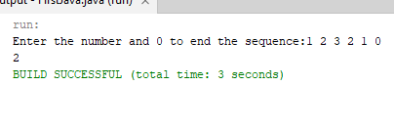

Graded Task 9:

import java.util.Scanner;
public class FirstJava
{
public static void main(String[] argd)
{
Scanner input = new Scanner(System.in);
char answer;

do
{
System.out.println(" Enter your choice between 1 and 5:");
int choice = input.nextInt();

switch(choice)
{
case 1:
System.out.println(" enter the number of rows:");
int n = input.nextInt();
for(int i = 1; i<=n ; i++)
{
for(int j = 1; j <=10; j++)
{
System.out.print("*");
}
System.out.println();

}
break;
case 2:
System.out.println(" enter the number of rows:");
n = input.nextInt();
for(int i = 1; i<=n ; i++)
{
for(int j = 1; j <=i; j++)
{
System.out.print("*");
}
System.out.println();

}
break;
case 3:
System.out.println(" enter the number of rows:");
n = input.nextInt();
for(int i = 1; i<=n ; i++)
{
for(int j = 1; j <=n-i; j++)
{
System.out.print(" ");
}
for(int k = 1; k <= i; k++)
{
System.out.print("*");
}
System.out.println();

}
break;
case 4:
System.out.println(" enter the number of rows:");
n = input.nextInt();
for(int i = 1; i<=n ; i++)
{
for(int j = 1; j <=n-i; j++)
{
System.out.print(" ");
}
for(int k = 1; k <=( 2 * i - 1); k++)
{
System.out.print("*");
}
System.out.println();

}
break;
case 5:
System.out.println(" enter the number of rows:");
n = input.nextInt();
for(int i = 1; i<=n ; i++)
{
for(int j = 1; j <=n-i; j++)
{
System.out.print(" ");
}
for(int k = 1; k <=( 2 * i + 1); k++)
{
System.out.print(i);
}
System.out.println();

}
break;
default: System.out.println(" Invalid choice! please enter between 1 and 4");

}
System.out.println(" Do you want to print another pattern? (y/n):");
answer = input.next().charAt(0);

}while(answer == 'y' || answer == 'Y');

System.out.println("Program terminated.");
}
}

OUTPUT:
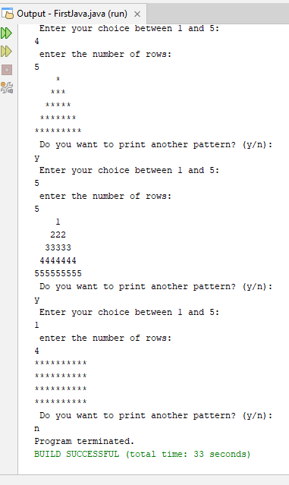

Graded Task 10:

import java.util.Scanner;

public class Firstjava
{
public static void main(String[] args)
{
Scanner input = new Scanner(System.in);

System.out.print("Enter year: ");
int year = input.nextInt();

System.out.print("Enter first day of the year (0=Sunday ... 6=Saturday): ");
int firstDay = input.nextInt();

int daysInMonth = 0;
String monthName = "";

for (int month = 1; month <= 12; month++) {

if (month == 1) {
monthName = "January";
daysInMonth = 31;
} else if (month == 2) {
monthName = "February";
if ((year % 400 == 0) || (year % 4 == 0 && year % 100 != 0))
daysInMonth = 29;
else
daysInMonth = 28;
} else if (month == 3) {
monthName = "March";
daysInMonth = 31;
} else if (month == 4) {
monthName = "April";
daysInMonth = 30;
} else if (month == 5) {
monthName = "May";
daysInMonth = 31;
} else if (month == 6) {
monthName = "June";
daysInMonth = 30;
} else if (month == 7) {
monthName = "July";
daysInMonth = 31;
} else if (month == 8) {
monthName = "August";
daysInMonth = 31;
} else if (month == 9) {
monthName = "September";
daysInMonth = 30;
} else if (month == 10) {
monthName = "October";
daysInMonth = 31;
} else if (month == 11) {
monthName = "November";
daysInMonth = 30;
} else if (month == 12) {
monthName = "December";
daysInMonth = 31;
}

System.out.println("\n\n\t\t" + monthName + " " + year);
System.out.println("Sun Mon Tue Wed Thu Fri Sat");

for (int i = 0; i < firstDay; i++) {
System.out.print(" ");
}

for (int day = 1; day <= daysInMonth; day++) {
System.out.printf("%3d ", day);

if ((day + firstDay) % 7 == 0)
System.out.println();
}
firstDay = (firstDay + daysInMonth) % 7;
System.out.println();
}

}
}

OUTPUT:
